Daily Stand-up Meeting
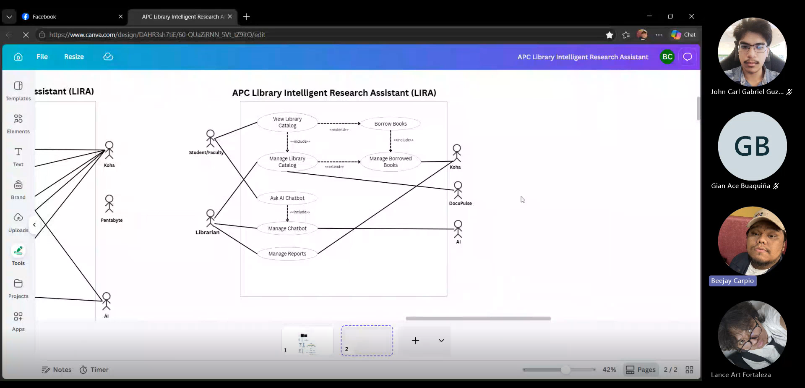

Minutes of meeting
Date: 09/17/2026
Meeting Called By: Cache Flow
Meeting Link: Daily Stand-Up Meeting-20260917_211437-Meeting Recording.mp4
Attendees
Gian Ace Buaquiña
Beejay A. Carpio
Lance Art P. Fortaleza
John Carl Gabriel Guzman

Summary
Following discussions with Sir Jojo, we will use Project Gutenberg as open-source sample data for e-books and integrate it with Koha to test CRUD operations for the managed library catalog. The Koha system will manage reports and book loans (including borrower names and student IDs), serving as the data source for search and view functions across student, faculty, and librarian roles.

What we did yesterday:
completed the student side dashboard UI and book catalog listing layout, populated the sample database, enabled and tested the functionality of dashboard buttons.

What we did today:
Implemented the book details feature (displaying titles and detail views upon clicking a sample book). Revise the C4 diagrams, user stories, and Use Case Full Description

